Track 1: AI for Accounting SW 1

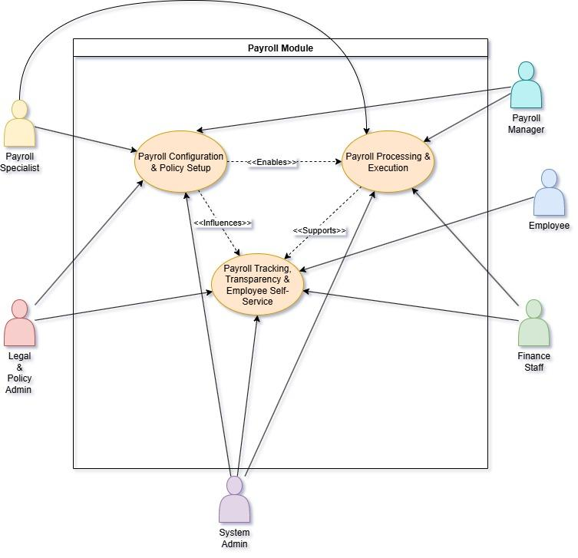
[Provide a figure such as the one above to prove a use-case to the product feature]

[Table of Contents]
Project Features 2
1. AI Chatbots for Continuous Feedback: Enhancing Employee Insights (e.g. job satisfaction) 2
1.1. Business Process 1 2
1.1.1. Use Cases 2
1.1.2. Business Process Diagram (BPMN) 4
1.1.3. User Stories 4
Field Requirements / Business Rules 5
Wireframe 5
Test Cases 5

Project Features

AI in General Ledger and Core Accounting

[Explain the feature, what is the focus of the feature and what processes are to be done]

Business Process 1
[Explain the business process that would occur, note: there should be more than one business process for a feature]

Use Cases
[Provide a use-case diagram that shows the proper use of business process] Use: Draw.io
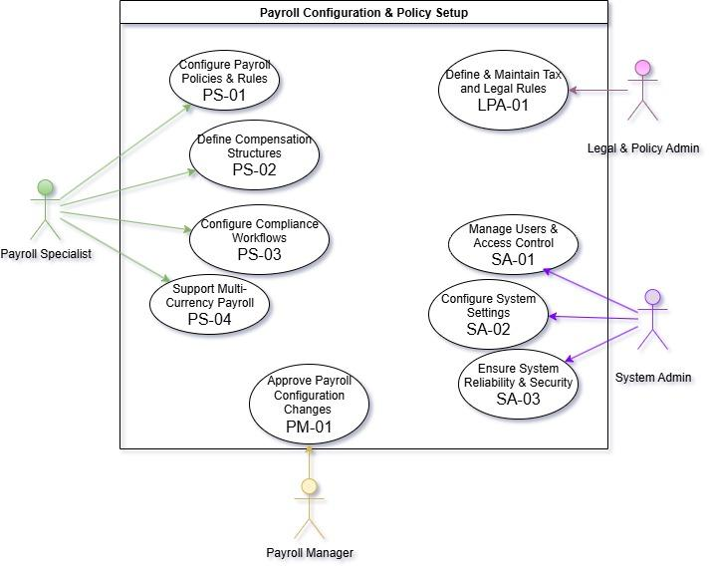

Business Process Diagram (BPMN)
[Provide a BPMN that helps you visualize your conceptual framework]
Use: https://camunda.com/
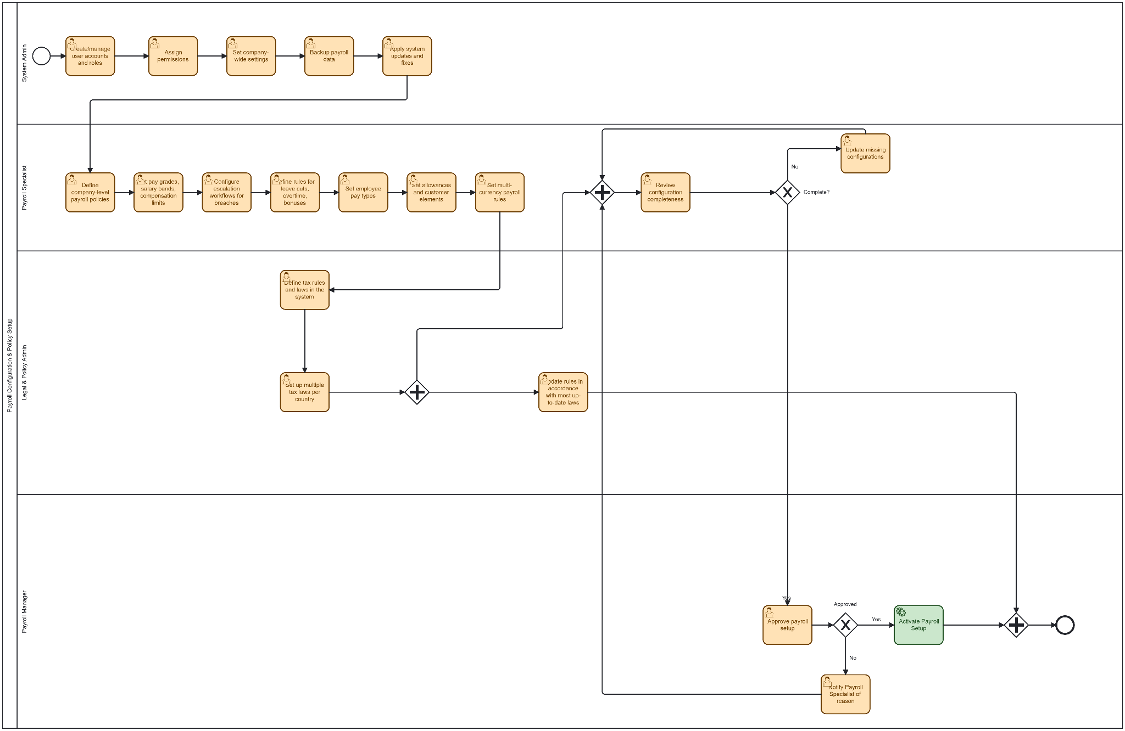

User Stories
[Create some user stories and split the business process into different epics to dive narrower into context]

Requirement ID | Epic | User Story Summary
REQ-PY-1 | Payroll Configuration & Policy Setup | As a Payroll Specialist, I want to configure company-level payroll policies (e.g., basic salary types, misconduct penalties, leave policies, allowance) so that the system enforces organizational rules consistently.
REQ-PY-2 | Payroll Configuration & Policy Setup | As a Payroll Specialist, I want to define pay grades, salary bands, and compensation limits so that managers and payroll specialists cannot exceed policy boundaries.

Field Requirements / Business Rules
[Provide some fields that shows up on the interface, and some business rules that limits the use within the product]

Wireframe
[Provide a link to the interface created as an example of what is expected to be shown]
Use: bolt.new

Test Cases
[Provide some test cases to check later if the solution created is viable or did some test cases not pass]

Test Case ID | Test Scenario | Test Steps | Expected Result
CFG-01 | Configure company-level payroll policies | 1) Log in as Payroll Specialist. 2) Navigate to Payroll → Policies. 3) Create a policy "Misconduct Penalty" with rule and percentage; create Leave Policy; create Allowance type. 4) Save and publish. 5) Attempt to apply a policy-restricted action in a simulated payroll run. | Policies saved, visible in list with status "Active". Simulated payroll respects rules (e.g., misconduct deduction applied), and policy change recorded in audit log.

